Tutorial 9
Q1
Indicate which register holds the TMRxIF (timer interrupt flag) bit of the following timers.
(a) Timer 0 (b) Timer 1

a) INTCON b) PIR1

Q2
Indicate when the TMR0IF is raised for each of the following modes:
(a) 16 bit (b) 8 bit

a) When the timer reaches its maximum value of FFFFH and it rolls over to 0000
b) When the timer reaches its maximum value of FFH and it rolls over to 00

Q3
Assume that XTAL=10MHz, Find the TMR0H, TMR0L value needed to generate a time delay of 2 ms. Use 16bit mode, no prescaler mode.

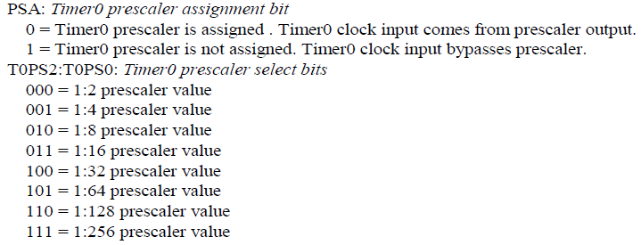

MOVLW 0x08 ;Timer0, 16-bit, int clk, no prescaler
MOVWF T0CON
MOVLW 0x??
MOVWF TMR0H
MOVLW 0x??
MOVWF TMR0L
BCF INTCON, TMR0IF
CALL DELAY
:
:
DELAY
BSF T0CON, TMR0ON
AGAIN
BTFSS INTCON, TMR0IF
BRA AGAIN
BCF T0CON, TMR0ON
RETURN

OR
MOVLW 0x08 ;Timer0, 16-bit, int clk, no prescaler
MOVWF T0CON

:
:
CALL DELAY
:
:
DELAY
MOVLW 0x??
MOVWF TMR0H
MOVLW 0x??
MOVWF TMR0L
BCF INTCON, TMR0IF
BSF T0CON, TMR0ON
AGAIN
BTFSS INTCON, TMR0IF
BRA AGAIN
BCF T0CON, TMR0ON
RETURN

10 MHz / 4 = 2.5 MHz, 1 / 2.5 MHz = 0.4 μs,
2 ms / 0.4 μs = 5000, 65536 – 5000 = 60536 = 0xEC78,
TMR0H = 0xEC TMR0L = 0x78

Q4
Assume that XTAL=10MHz, Find the TMR0H, TMR0L value needed to generate a time delay of 5 ms. Use 16bit mode, 256 prescaler mode.

MOVLW 0x07
MOVWF T0CON

10 MHz / 4 = 2.5 MHz, 1 / 2.5 MHz = 0.4 μs,
5 ms / 0.4 μs = 12500, 12500 / 256 = 49, 65536 – 49 = 65487 = 0xFFCF,
TMR0H = 0xFF TMR0L = 0xCF

Q5
Assume that XTAL=20MHz, Find the TMR1H, TMR1L value needed to generate a time delay of 2 ms. Use 16bit mode, 8 prescaler mode.

MOVLW 0x30
MOVWF T1CON

MOVLW 0x??
MOVWF TMR1H
MOVLW 0x??
MOVWF TMR1L
BCF PIR1, TMR1IF
CALL DELAY
BTG PORTB,5
BRA HERE
DELAY
BSF T1CON, TMR0ON
AGAIN
BTFSS PIR1, TMR1IF
BRA AGAIN
BCF PIR1 TMR1ON
RETURN

OR
MOVLW 0x30
MOVWF T1CON

CALL DELAY
:
:

DELAY
MOVLW 0x??
MOVWF TMR1H
MOVLW 0x??
MOVWF TMR1L
BCF PIR1, TMR1IF
BSF T1CON, TMR0ON
AGAIN
BTFSS PIR1, TMR1IF
BRA AGAIN
BCF PIR1 TMR1ON
RETURN

20 MHz / 4 = 5 MHz, 1 / 5 MHz = 0.2 μs,
2 ms / 0.2 μs = 10000, 10000 / 8 = 1250, 65536 – 98 = 0xFF9E,
TMR0H = 0xFB TMR0L = 0x1E

Q6
Program Timer0 to generate a square wave of 1 kHz. Assume that XTAL=10 MHz,

- F=1KHz, T=1ms
- Delay=0.5 ms
- 0.5ms/0.4 μs=1250
- 65536-1250=FB1E

ORG 0x00
GOTO START
ORG 0x30
START BCF TRISB,4
MOVLW 0x08
MOVWF T0CON
HERE MOVLW 0xFB
MOVWF TMR0H
MOVLW 0x1E
MOVWF TMR0L
BCF INTCON,TMR0IF
CALL DELAY
BTG PORTB,RB4
BRA HERE

DELAY
BSF T0CON,TMR0ON
AGAIN BTFSS INTCON,TMR0IF
BRA AGAIN
BCF T0CON,TMR0ON
RETURN
END
Q7
Program Timer1 to generate a square wave of 3 kHz. Assume that XTAL=10 MHz,
Use the largest prescaler possible,
Timer1, max prescaler =8

- F=3KHz, T=0.333ms
- Delay=0.167 ms
- 0.167ms/0.4 μs=416
- 416=52

- 65536-52=FFCC

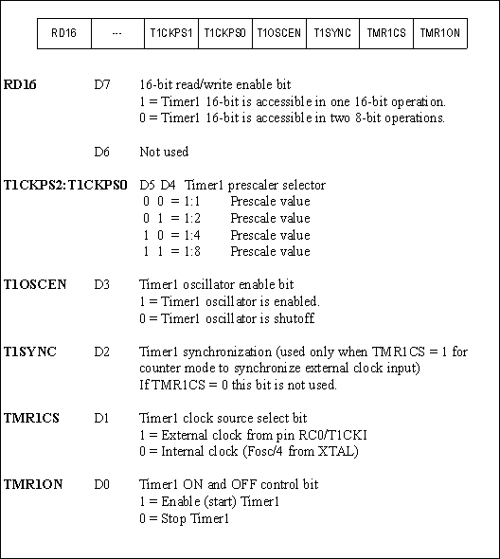

ORG 0x00
GOTO START
ORG 0x30
START BCF TRISB,5
MOVLW 0x30
MOVWF T1CON
HERE MOVLW 0xFF
MOVWF TMR1H
MOVLW 0xCC
MOVWF TMR1L
BCF PIR1,TMR1IF
CALL DELAY
BTG PORTB,RB5
BRA HERE
DELAY BSF T1CON,TMR1ON
AGAIN BTFSS PIR1,TMR1IF
BRA AGAIN
BCF PIR1,TMR1ON
RETURN
END

Q8
Program Timer 1 to be an event counter. Use 16 bit mode, and display the binary count on PORTB and PORTD continuously. Set initial count to 0

ORG 0x00
GOTO START
ORG 0x30
START BSF TRISC,0
CLRF TRISB
CLRF TRISD
MOVLW 0x02
MOVWF T1CON
HERE MOVLW 0x00
MOVWF TMR1H
MOVLW 0x00
MOVWF TMR1L
BCF PIR1,TMR1IF
BSF T1CON,TMR1ON
AGAIN MOVFF TMR1H,PORTD
MOVFF TMR1L,PORTB
BTFSS PIR1,TMR1IF
BRA AGAIN
BCF T1CON,TMR1ON
GOTO HERE
END

Q9
Program Timer0 to be an event counter. Use 8 bit mode and display the binary count on PORTB continuously. Set initial count to be 20.

If T0CS = 1, the timer is used as a counter. TMR0 count up (NOT count down)
Counts up as pulses are fed from pin RA4 (T0CKI)

ORG 0x00
GOTO START
ORG 0x30
START BSF TRISA,RA4
CLRF TRISB
MOVLW 0x68
MOVWF T0CON
HERE
MOVLW 0x14
MOVWF TMR0L
BCF INTCON,TMR0IF
BSF T0CON,TMR0ON
AGAIN
MOVFF TMR0L,PORTB
BTFSS INTCON,TMR0IF
BRA AGAIN
BCF T0CON,TMR0ON
GOTO HERE
END

Q10
Write a program using timer0 interrupt to create a square wave of 1 Hz. On RB7 while data from PORTC is being sent to PORTD. Assume that XTAL=10MHz

Every 0.5 Second generate an interrupt to toggle RB7.

0.5 s/ 0.4 μs = 1250000
1250000/256 = 4883
65536-4883=ECED

ORG 0000H
GOTO MAIN ;bypass interrupt vector table
ORG 0008H ; interrupt vector table
BTFSS INTCON,TMR0IF ;Timer0 interrupt?
RETFIE ; No. Then return to main
GOTO T0_ISR ;Yes. Then go Timer0 ISR

;—-main program
ORG 00100H ;after vector table space
MAIN
BCF TRISB,7 ;RB7 as an output
CLRF TRISD ;make PORTD output
SETF TRISC ;make PORTC input
MOVLW 0x07 ;Timer0,16-bit 256 prescale,internal clk
MOVWF T0CON ;load T0CON reg
MOVLW 0xEC ;TMR0H = ECH, the high byte
MOVWF TMR0H ;load Timer0 high byte
MOVLW 0xED ;TMR0L = EDH, the low byte
MOVWF TMR0L ;load Timer0 low byte
BCF INTCON,TMR0IF ;clear timer interruupt flag bit
BSF T0CON,TMR0ON ;start Timer0
BSF INTCON,TMR0IE ;enable Timer 0 interrupt
BSF INTCON,GIE ;enable interrupts globally

;--keeping CPU busy waiting for interrupt
OVER MOVFF PORTC,PORTD ;send data from PORTC to PORTD
BRA OVER ;stay in this loop forever
;--------------------------ISR for Timer 0
T0_ISR
ORG 200H
MOVLW 0xEC ;TMR0H = ECH, the high byte
MOVWF TMR0H ;load Timer0 high byte
MOVLW 0xED ;TMR0L = EDH, the low byte
MOVWF TMR0L ;load Timer0 low byte
BTG PORTB,7 ;toggle RB7
BCF INTCON,TMR0IF ;clear timer interrupt flag bit
EXIT RETFIE ;return from interrupt (See Example 11-2)
END

Q11
Write a program using timer1 interrupt to create a square wave of 3 kHz. On RB7 while data from PORTC is being sent to PORTD. Assume that XTAL=10MHz

Every 0.167 ms Second generate an interrupt to toggle RB7.
0.167 ms/ 0.4 μs = 417
65536-417=FE5E

ORG 0000H
GOTO MAIN ;bypass interrupt vector table
;—-on default all interrupts land at address 00008
ORG 0008H ;interrupt vector table
BTFSS PIR1,TMR1IF ;Timer1 interrupt?
RETFIE ;No. Then return to main
GOTO T1_ISR ;Yes. Then go Timer1 ISR
;—-main program for initialization and keeping CPU busy
ORG 00100H ;after vector table space
MAIN
BCF TRISB,7 ;RB7 as an output
CLRF TRISD ;make PORTD output
SETF TRISC ;make PORTC input
CLRF T1CON ;Timer1,16-bit,
;no prescale,internal clk
MOVLW 0xFE ;TMR1H = FEH, the high byte
MOVWF TMR1H ;load Timer0 high byte
MOVLW 0x5F ;TMR1L = 5EH, the low byte
MOVWF TMR1L ;load Timer1 low byte
BSF PIE1,TMR1IE ;enable Timer1 interrupt
BCF PIR1,TMR1IF ;clear timer interruupt flag bit
BSF T1CON,TMR1ON ;start Timer1
BSF INTCON,PEIE ;enable peripheral interrupts
BSF INTCON,GIE ;enable interrupts globally
;--keeping CPU busy waiting for interrupt
OVER MOVFF PORTC,PORTD ;send data from PORTC to PORTD
BRA OVER ;stay in this loop forever
;--------------------------ISR for Timer 0
T1_ISR
ORG 200H
MOVLW 0xFE ;TMR1H = FEH, the high byte
MOVWF TMR1H ;load Timer1 high byte
MOVLW 0x5F ;TMR1L = 5FH, the low byte
MOVWF TMR1L ;load Timer1 low byte
BTG PORTB,7 ;toggle RB7
BCF PIR1,TMR1IF ;clear timer interrupt flag bit
EXIT
RETFIE
END

